Ai assisted coding Assignment-13.4
Name:E.Srivarsha
Batch-44
HTNO:2303a52343
Task 1: Refactoring Data Transformation Logic
Prompt:
Refactor this Python loop to a more Pythonic way using list comprehension.
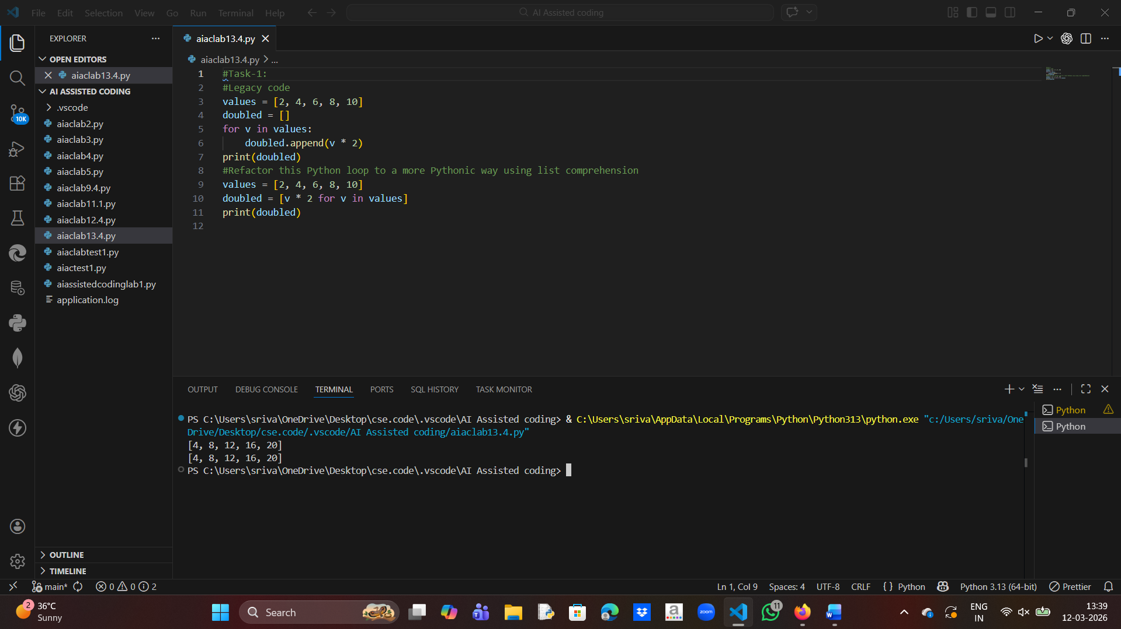
Explanation
The original code used a loop and append() to create a new list. Using list comprehension makes the code shorter, cleaner, and faster.

Task 2: Improving Text Processing Code Readability
Prompt :
Improve this Python code that concatenates strings in a loop.

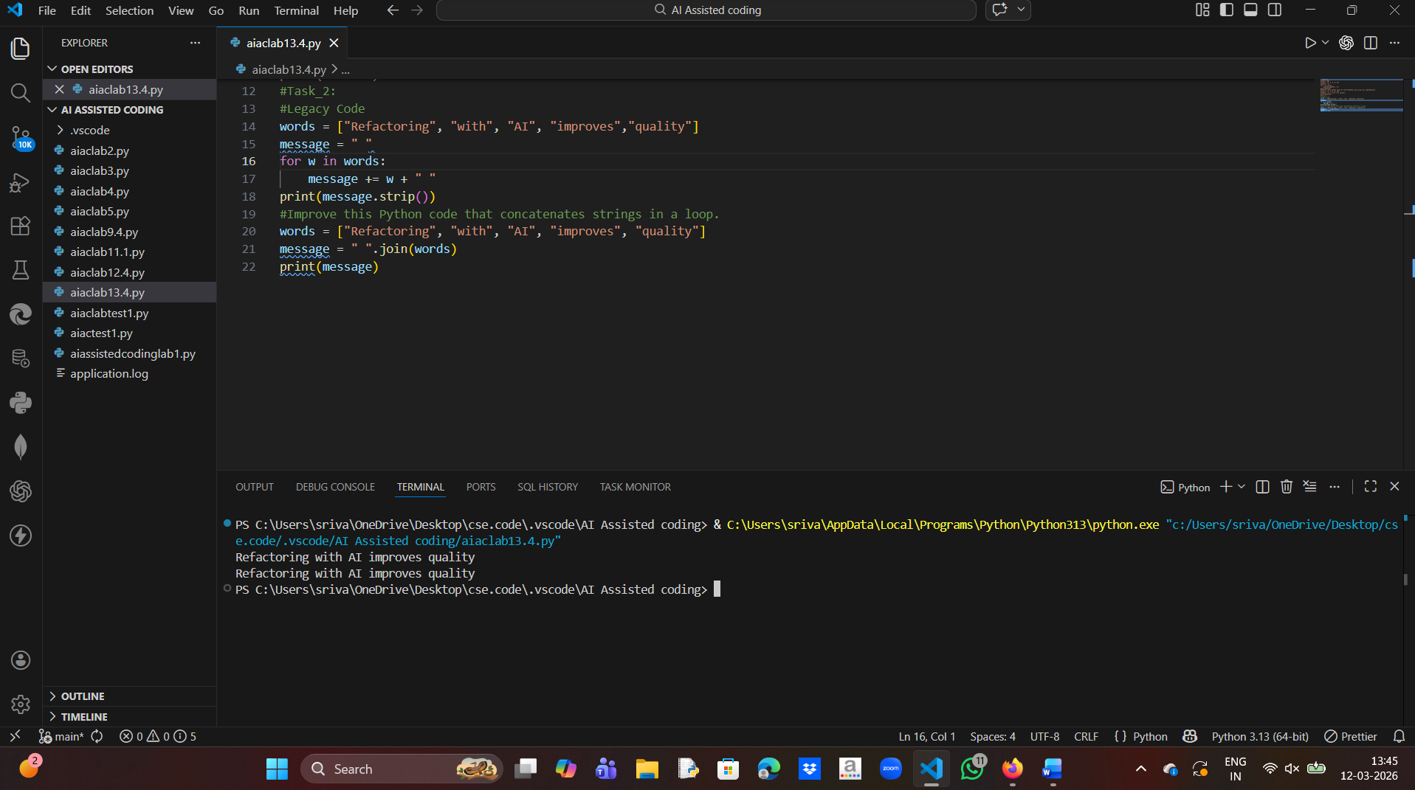
Explanation
The original code repeatedly concatenated strings which is inefficient.
Using " ".join() combines all words with a space and improves performance and readability

Task 3: Safer Access to Configuration Data
Prompt:
Refactor dictionary access using safer methods in Python.
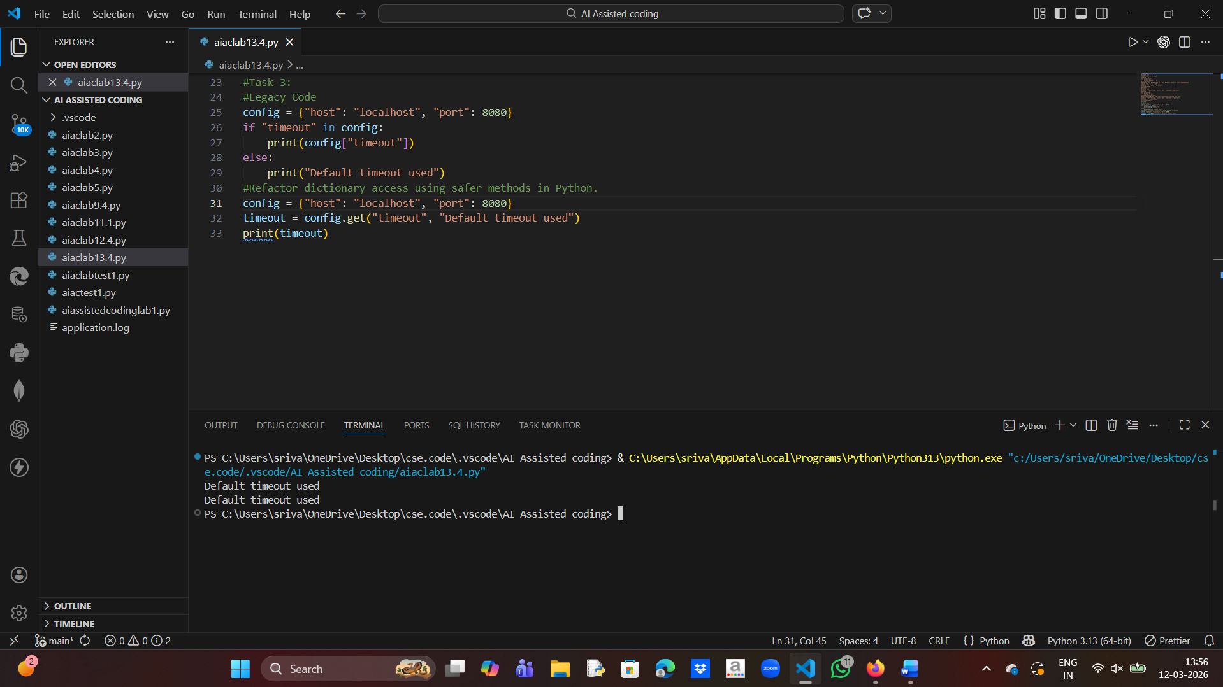
Explanation
Instead of checking keys manually using if, the get() method safely retrieves the value.
If the key does not exist, it returns the default value.

Task 4: Refactoring Conditional Logic for Scalability
Prompt:
Replace multiple if-elif conditions with a scalable mapping approach.
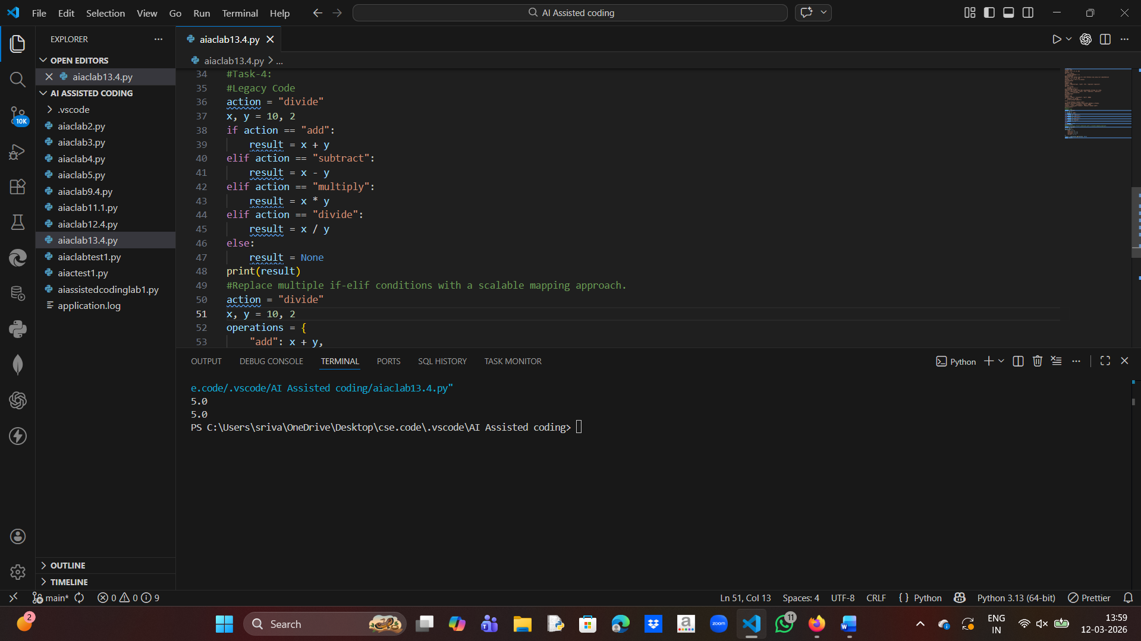
Explanation
Instead of many if-elif statements, a dictionary mapping is used.
This approach is cleaner and easier to extend when new operations are added.

Task 5: Simplifying Search Logic in Collections
Prompt:
Refactor this loop search into a more concise Python expression.
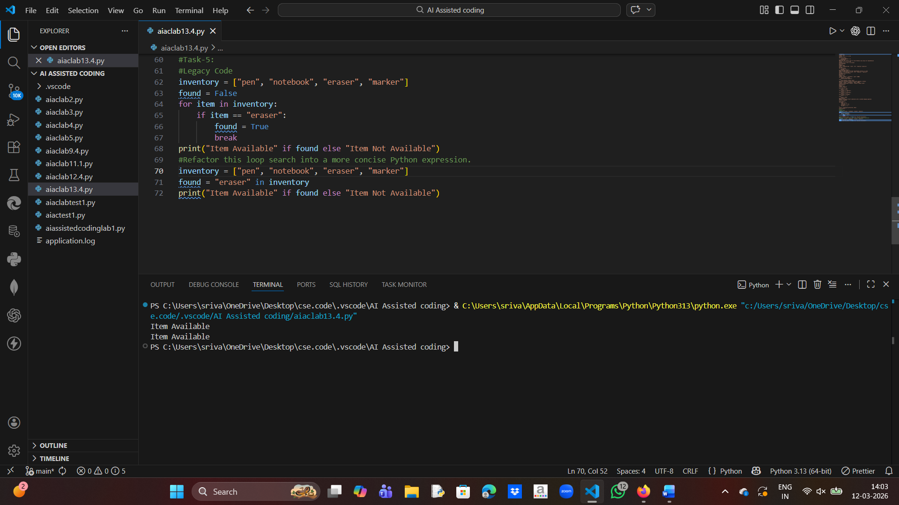

Explanation
The original code used a loop to search an item.
Python provides the in operator which directly checks if an element exists in a list.

